# Running QAQC Tool

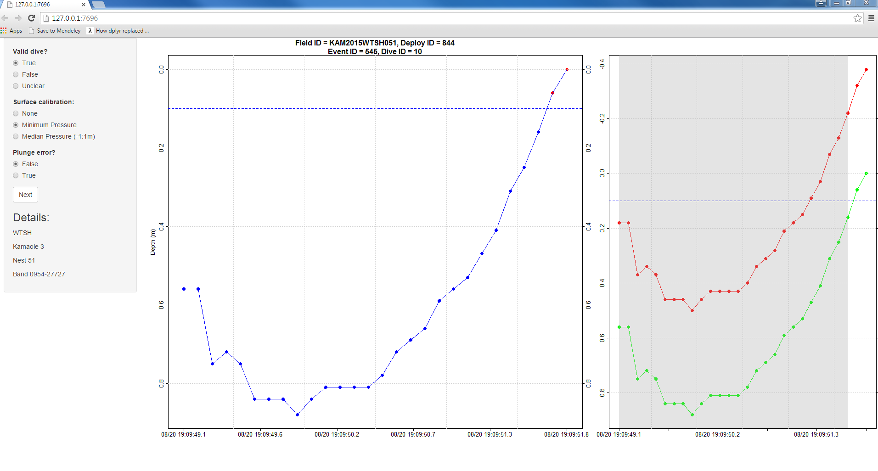

A browser-based tool for rapidly verifying dive data. Runs locally using the shiny package for R.

## Setup

1. Sync with GitHub
   1. Commit ea5e7c on 5/24/2016 contains the relevant code.
   2. Sync to the master branch to get up to date.
2. Sync with Google Drive
   1. You’ll need the files in www. This folder is saved in Google Drive under tracking_data/TDR/QAQC/WTSH. Note: this will take some time as it is a very large folder.
   2. Download www and extract it to WERC-SC/dive_identification/QAQC.
3. Download necessary R packages
   1. Open RStudio
   2. If you’re missing either of the following packages, install them:
      1. shiny
      2. dplyr
4. Run app
   1. From within RStudio, open WERC-SC/dive_identification/QAQC/ui.R.
   2. Set the app to Run External using the dropdown in the top right corner of the code frame

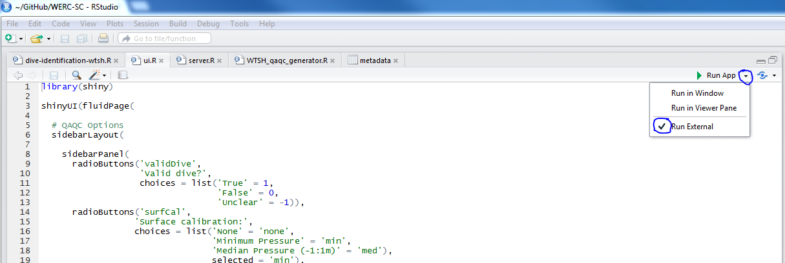

* 1. Click on the green play arrow to open the app in your browser

## Using the App

* TODO
  + indicate if threshold
  + Add option for split error
* valid dive
  + Be conservative, use Unclear if you’re questioning it
* surface calibration
  + None = do nothing, the red points in the right frame appear correct

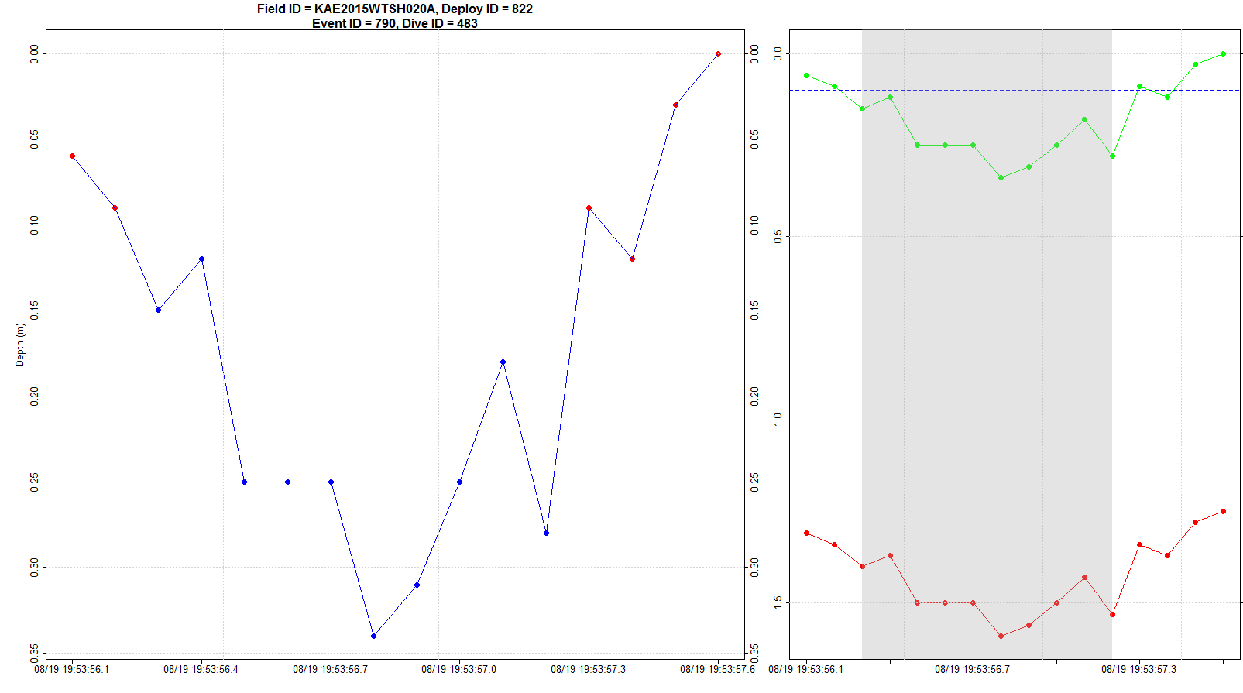

* + Minimum Pressure = set surface (i.e. 0m) to minimum pressure e.g.

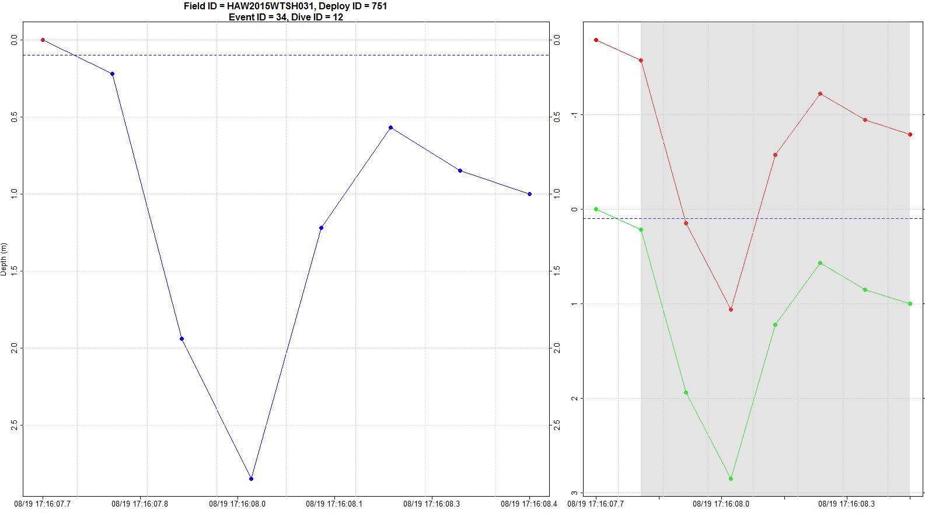

* + Median Pressure = set surface (i.e. 0m) to median of pressures between [-1,1]m e.g.
* errors
  + Plunge error if initial pressure spike

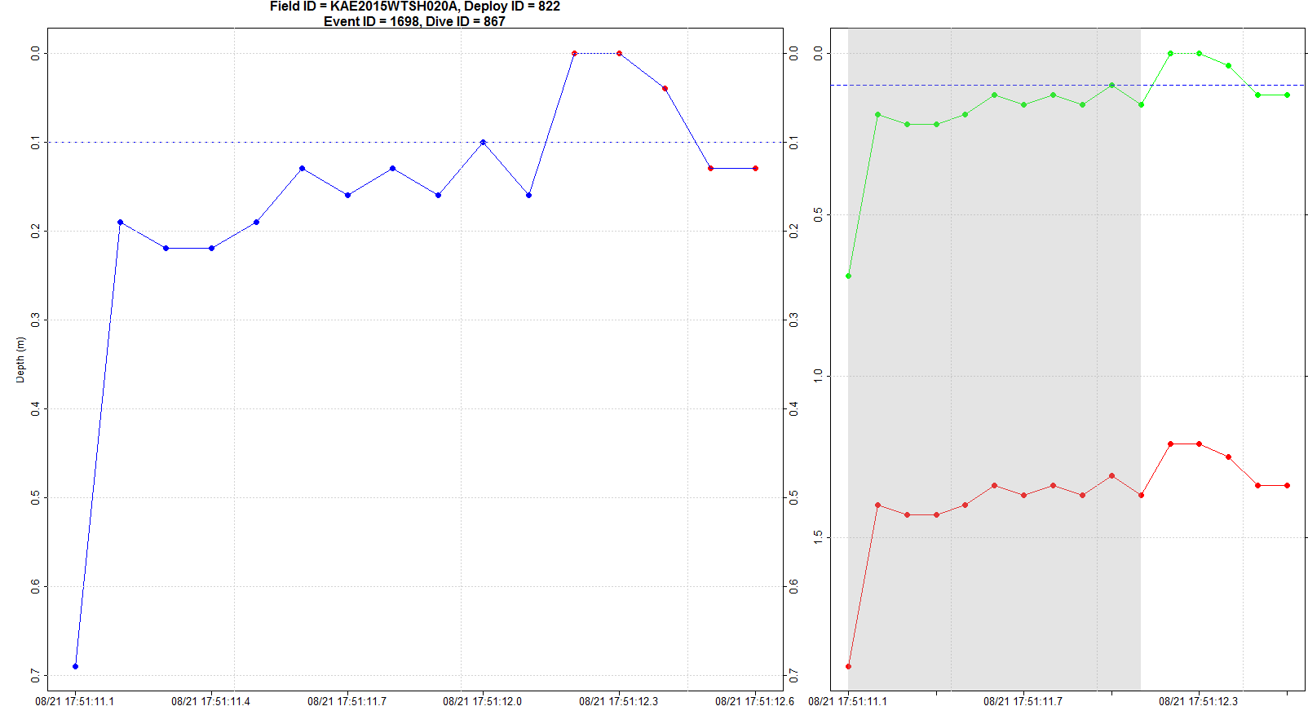

* + Split error if surface noise incorrectly causes one dive to be split into multiple dives

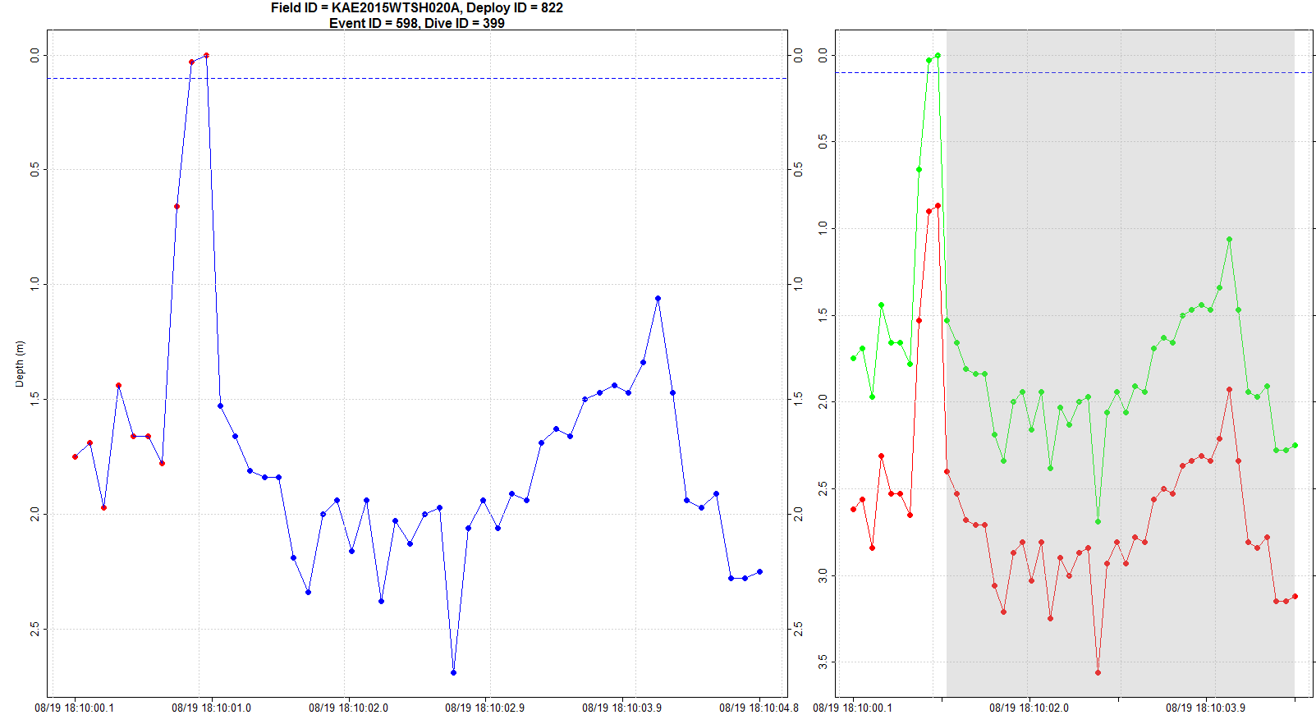

* Plots:
  + Left frame
    - Blue points – points within dive
    - Red points – points surrounding dive provided for context
  + Right frame
    - Red points – uncalibrated (nor surface offset applied)
    - Green points – calibrated (surface offset defaults to minimum pressure)